About elgg data model.

In Elgg, everything runs on a unified data model, based on atomic units of data called entities

Elgg is underpinned by a flexible, generic data model. This means that should new database functionality be introduced, or if a new data back-end is inserted to support multiple servers or other infrastructure requirements, you won't need to update your plugins and custom code.

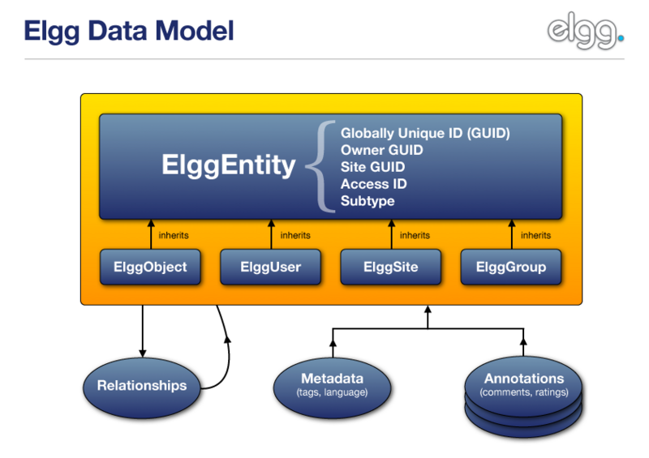

The graph is a really great description of elgg data model.

ElggEntity is the base class for the Elgg data model.

**ElggEntity** has four main specializations, which provide extra properties and methods to more easily handle different kinds of data.

[**ElggObject**](http://docs.elgg.org/wiki/Engine/DataModel/Entities/ElggObject)**:** Usually content like blog posts, uploaded files and bookmarks. We can use ElggObject is a kind of user’s behavior. There are public member functions for us to handle it.

We can load or create a new ElggObject; load or create a new [ElggObject](http://reference.elgg.org/classElggObject.html); return sites that this object is a member of; return sites that this object is a member of; return sites that this object is a member of; set if the object can be commented.

[**ElggUser**](http://docs.elgg.org/wiki/Engine/DataModel/Entities/ElggUser)**:** each user in the system

ElggUser is a good type of data for a social network user. It provides many functions about the relationship of user and friends, groups, admin and so on.

[**ElggSite**](http://docs.elgg.org/wiki/Engine/DataModel/Entities/ElggSite)**:** each site within an Elgg install.

Personal idea is that ElggSite is a kind of data connect the database. We can do something to the user and object in the database.

[**ElggGroup**](http://docs.elgg.org/wiki/Engine/DataModel/Entities/ElggGroup)**:** multi-user collaborative systems.

It can be used for relationships between users and users, users and objects, objects and objects.

So I think if we use the elgg data model for our social network, we can use

**ElggObject**

Blog, forum, sharing file, and other behavior of the user

**ElggUser**

The users of social network

**ElggGroup**

The relationships of users

The tags

The benefit of this kind of data model is that it packages some content and the function of the content in a data model type. So people can share the data and the code. It is very efficient to combine different people’s work. Otherwise it may cause many incompatible data problems. It is extremely important for a project with different groups taking charge of different tasks.

Plugins are strongly discouraged from dealing with database issues themselves, which makes for a more stable system that also has visible benefits for the end user. Content created by different plugins can be mixed together in consistent ways, which are programmed using generic principles - in other words, plugins are faster to develop, and are at the same time much more powerful.

As to metadata and annotations, they are extended entities with extra information.

[**Metadata**](http://docs.elgg.org/wiki/Engine/DataModel/Metadata) can add to an object to describe it further, for example, tags, an ISBN number, a file location or language.

[**Annotations**](http://docs.elgg.org/wiki/Engine/DataModel/Annotations): Information generally added by third parties which adds to the information provided by the entity. For example, comments and ratings are both annotations.

In short, the Elgg data model fully give an expression of social network engine. It is the relationship, interaction between users as well as objects. The data turns to a package, if we choose it, we can get some kind of “relate function”.